PRACTICAL – 5
1 Write a Shell script to accept a string as command line argument
and reverse the same.
INPUT:
# Get the input string
read a
string=$a
# Reverse the string
reversed_string=$(echo $string | rev)
# Print the result
echo "The reversed string of '$string' is '$reversed_string'"

OUTPUT:
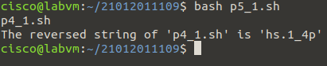

2. Write a shell script to calculate the loss percentage of an article, given the cost price and the selling price as command line arguments.
INPUT:
# Get the cost price
cost_price=$1
# Get the selling price
selling_price=$2
# Calculate the loss
loss=$(echo "($cost_price - $selling_price) / $cost_price * 100" | bc -l)
# Print the result
echo "The loss percentage is $loss%"

OUTPUT:
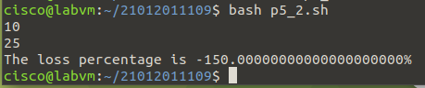
3. Write a shell script to accept the name of the user and check out if the same has logged in or not using command line arguments.
INPUT:
# Get the input user name
read a
username=$a
# Check if the user is logged in
logged_in=$(who | grep $username | wc -l)
# Print the result
if [ $logged_in -eq 0 ]; then
echo "User '$username' is not logged in."
else
echo "User '$username' is logged in."
fi

OUTPUT:
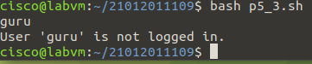
4. Write a shell script to check whether the file whose name is scanned exists and readable. Using command line arguments.
INPUT:
# Get the input file name
read a
file=$a
# Check if the file exists
if [ ! -f $file ]; then
echo "File not found."
exit 1
fi
# Check if the file is readable
if [ ! -r $file ]; then
echo "File is not readable."
exit 1
fi
echo "File exists and is readable."

OUTPUT:
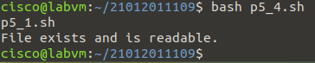

5. Write a shell script to check if the input string is a palindrome. command line argument
INPUT:

6. Write a shell script to accept a number and a word as command line arguments and print the word the given number of times on each line.
7. Write a shell script to find the file or directory with the maximum size in the current directory.
8. Write a shell script to accept two filenames and check if both exist. If the second filename exists, then the contents of the first filename should be appended to it. If the second filename does not exist, then create a new file with the contents of the first file.
9. Write a shell script to accept a number in the command line and displays the sum up to that number. By default, the sum up to 50 should be displayed.
10. Write a shell script to find the number of ordinary files and directory files in the current directory.
11. Write a shell script to accept an alphabet from the user and list all the files/directory starting with that alphabet in the current directory.

